**Figures & Summary Statements**

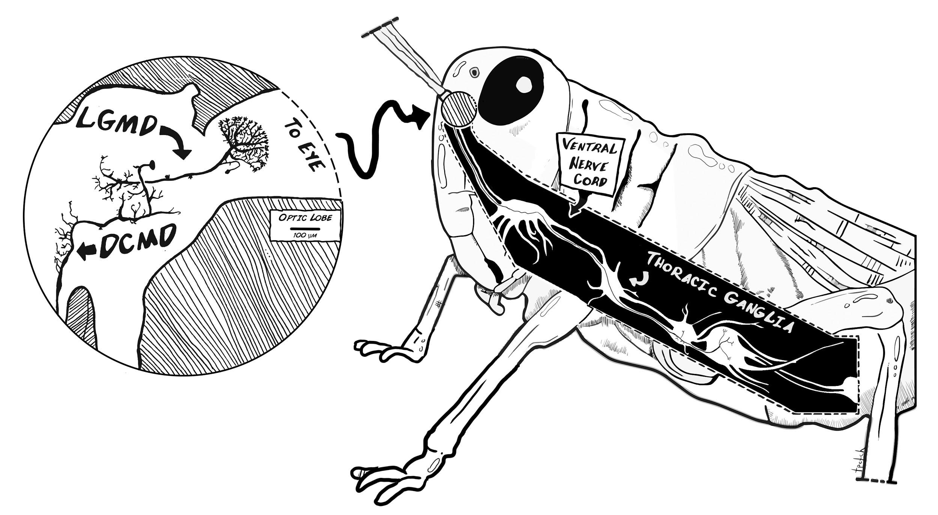

**Fig 1. Neuroanatomy of the grasshopper’s motion detector neurons.** The grasshopper optic lobes (lamina, medulla and lobula) lie in the central brain beneath each of the compound eyes and processes visual information. The lobula giant motion detectors (LGMDs) receive visual signals from the lobula and pass these inputs to the descending contralateral motion detectors (DCMDs). The LGMDs respond to motion of an object seen moving across the insect eye as well as to the looming effect, where the object increases in size as it approaches the eye. The DCMD activates motor neurons in the thoracic ganglia. These primary motion detector neurons underpin the animal’s detector and motor response to a looming object, forming the see-and-jump escape mechanism.

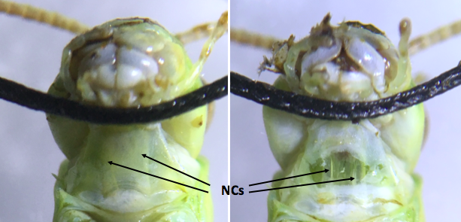

**Fig 2. Ventral view of the grasshopper neck showing the axonal pathways from the head to the thoracic ganglia. (Left)** Axonal bundles are visible as white stripes under the neck skin. **(Right)** A simple neck cut exposes the axonal bundles, two translucent tubes, where the part of the ventral nerve cord can be found. Placing a hook electrode around one bundle and exposing the contralateral eye to looming visual stimuli allows DCMD activity to be recorded.

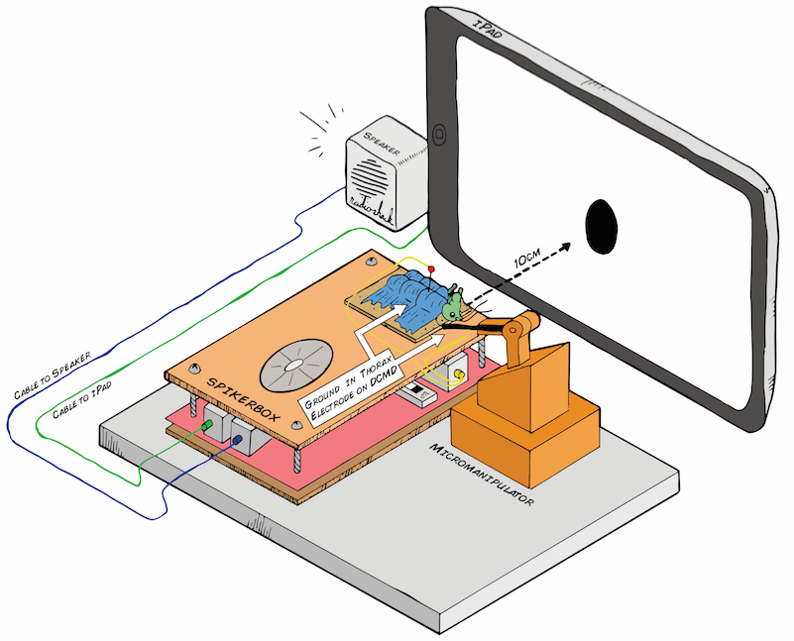

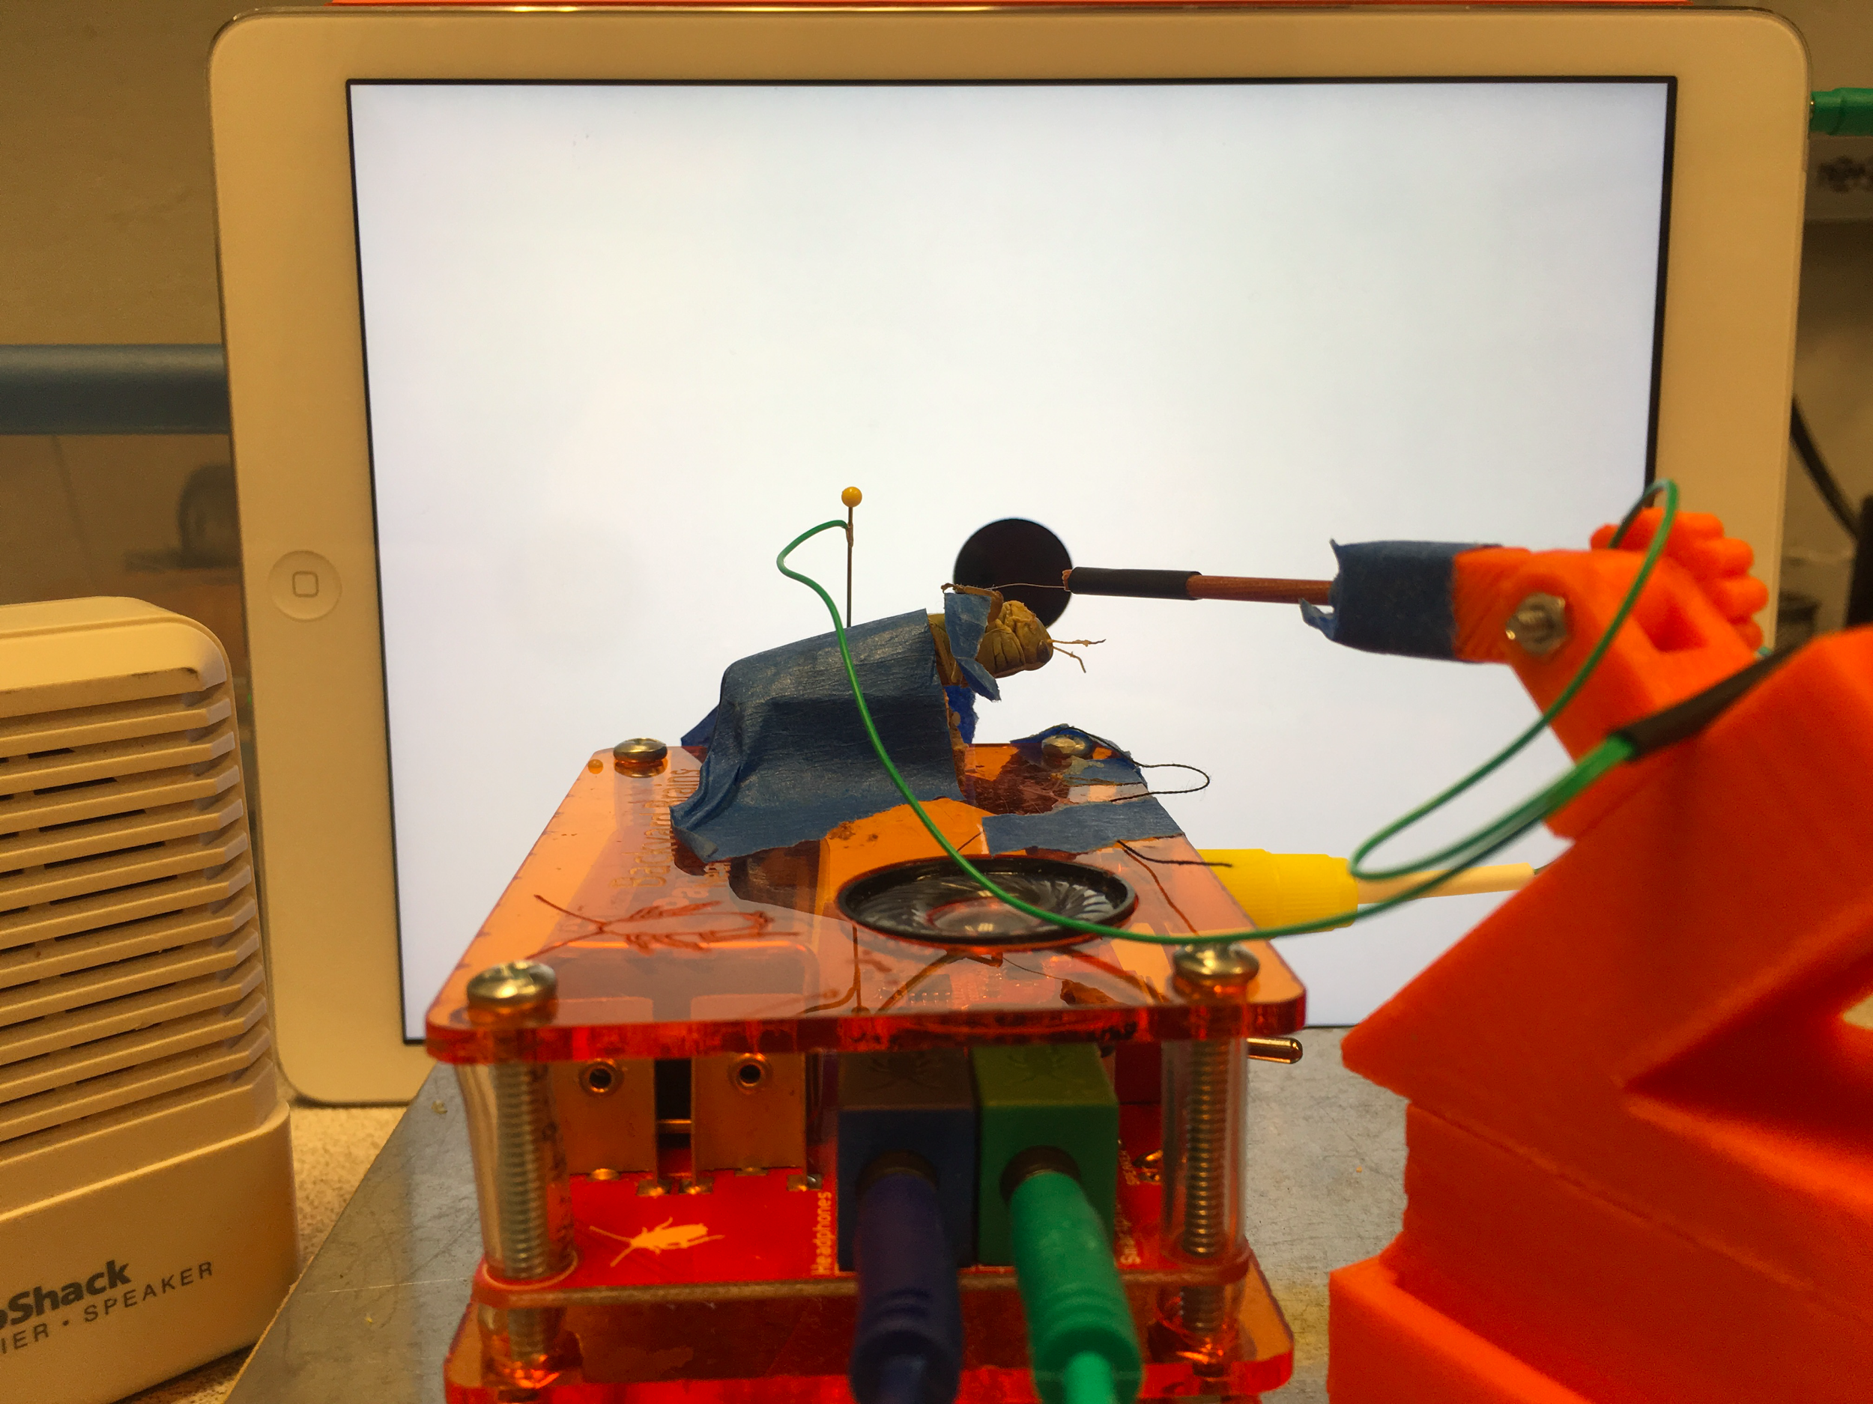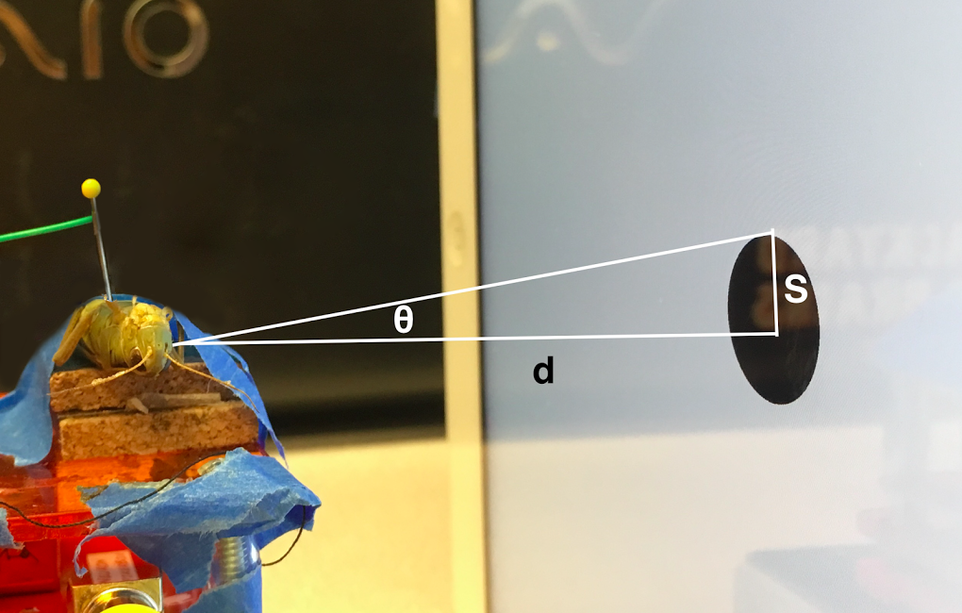

**Fig 2. Experimental setup to measure descending contralateral movement detector (DCMD) activity during simulated stimulus presentation.** **(Top)** Schematic representation of the experimental setup, grasshopper is taped down onto the corkboard on top of the SpikerBox. The reference electrode is grounded at the thorax and the recording hook electrode, guided by the 3D printed micromanipulator for precision, is placed around the neck connective where the ventral nerve cord and DCMD neuron’s axon is found. The iPad presenting the visual stimuli is placed 10cm from the grasshopper’s eye and the angle between the grasshopper’s eye and the center of the iPad is minimized. **(Bottom left)** Photograph of the apparatus. **(Bottom right)** Visual stimuli are displayed on the iPad to simulate the looming effect of an object approaching the grasshopper. The radius S` subtending angle θ, of a filled black dot can be manipulated to simulate, upon the retina of the insect, a fixed sized object (S) approaching at a particular constant velocity (v). DCMD recordings can be made during visual simulations of different sized objects moving at different velocities.

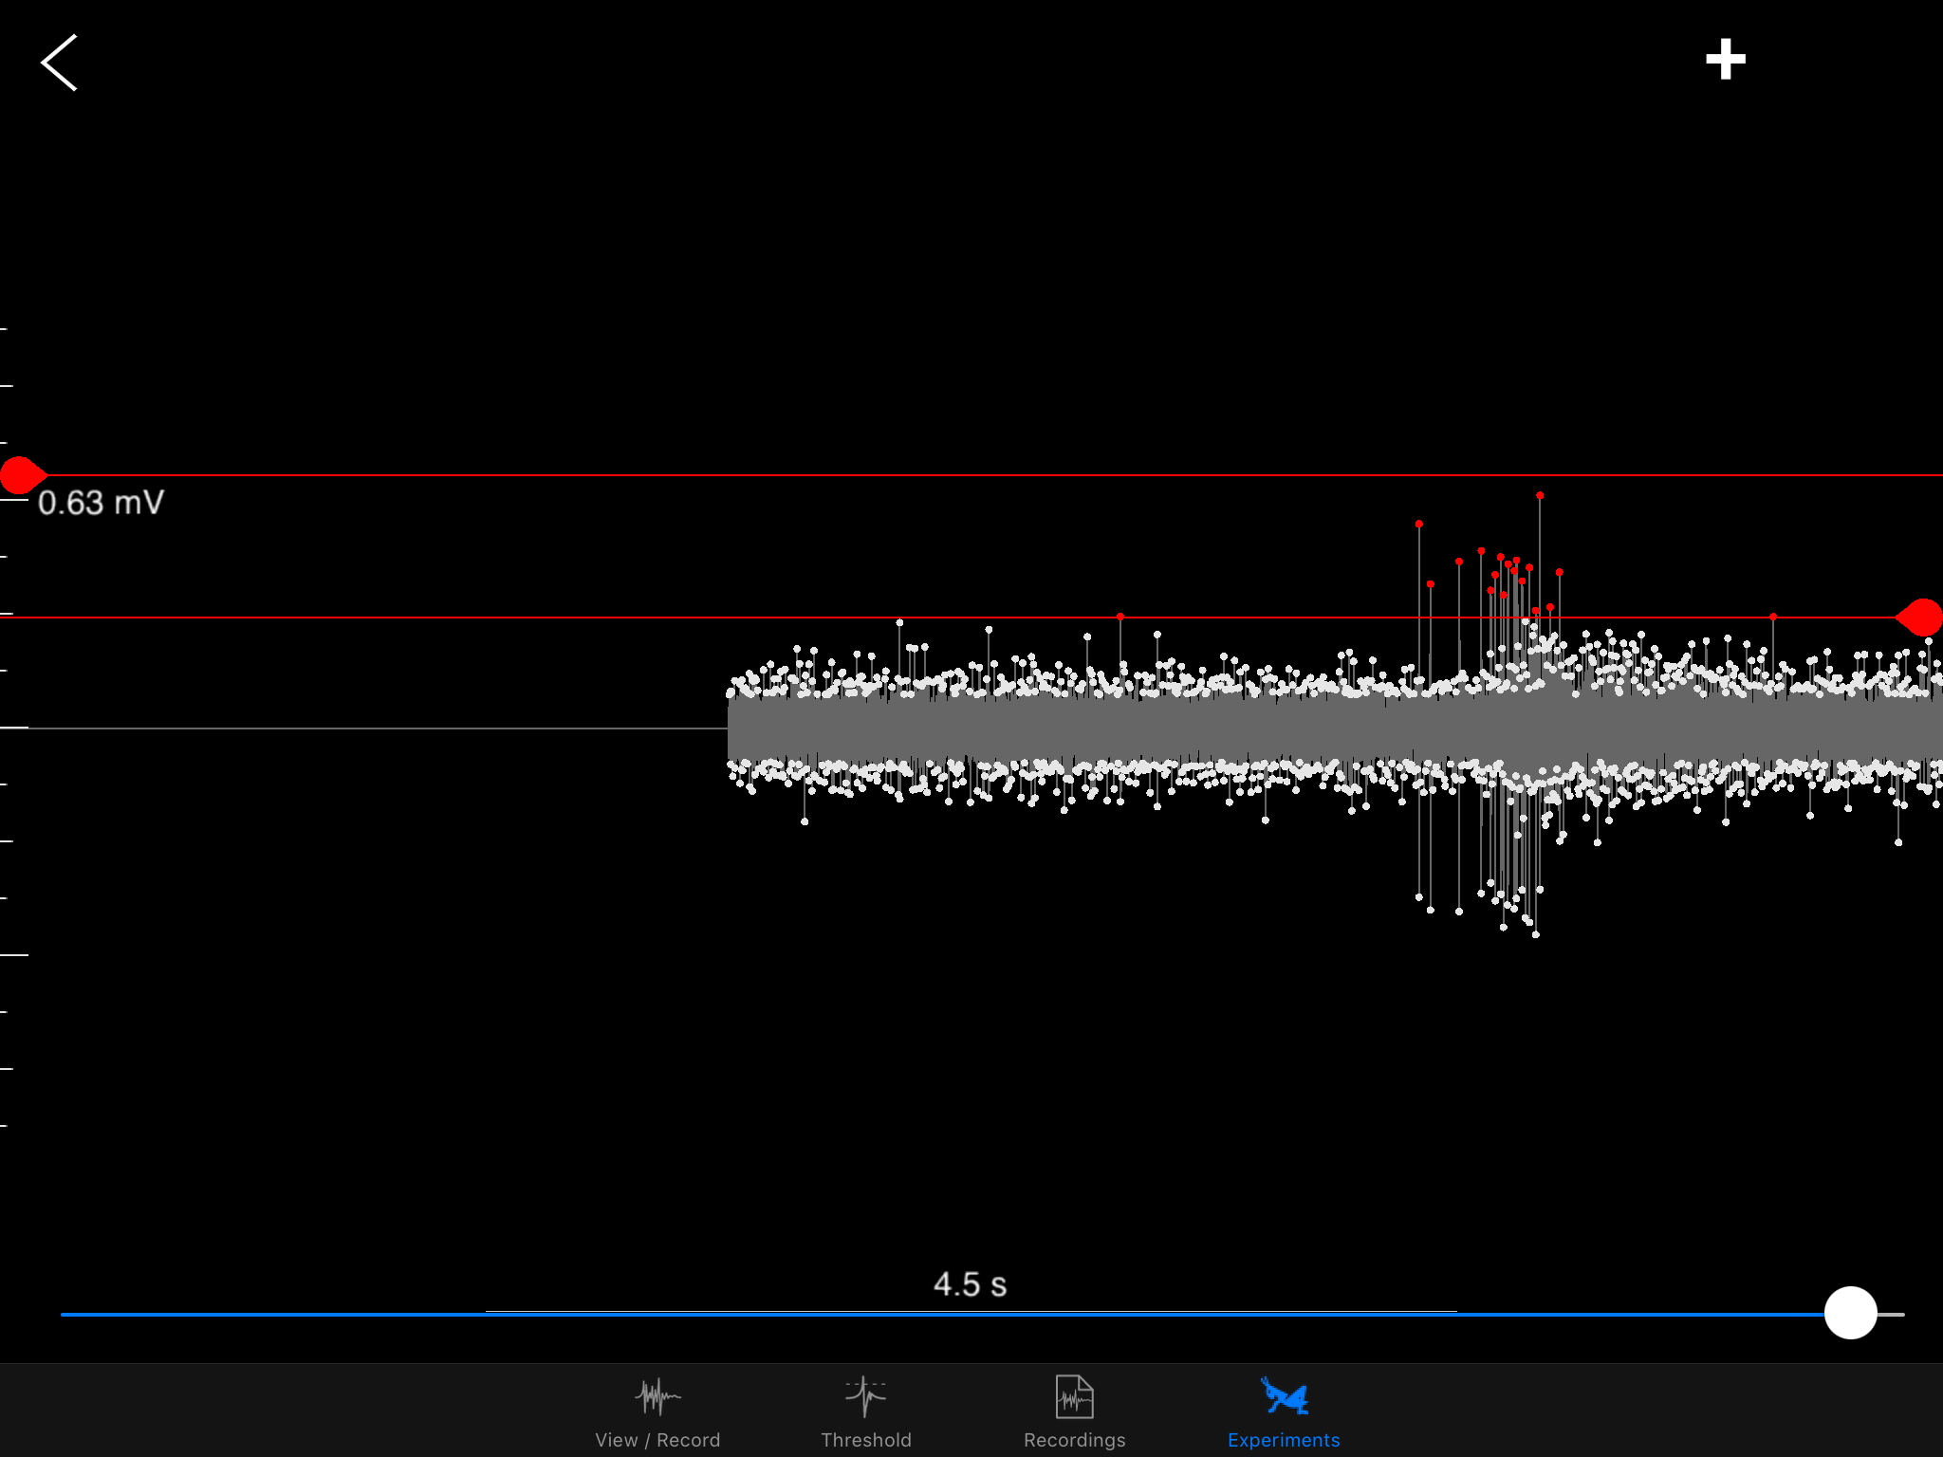

**Fig 3. Spike sorting in the SpikeRecorder iPad app.** SpikeRecorder provides both the looming visual stimuli and recording and analysis of DCMD activity. DCMD spikes can be sorted from noise after recording for analysis by providing minimum and maximum spike threshold values, these values can be applied to all recording made within a single grasshoppers experimental session. Image above shows iPad output of the DCMD recordings during a looming experiment (object size S = ??, velocity v = ??) with a minimum spike amplitude of ??, maximum of 0.63mV, red dots show those spikes recorded within the thresholds.

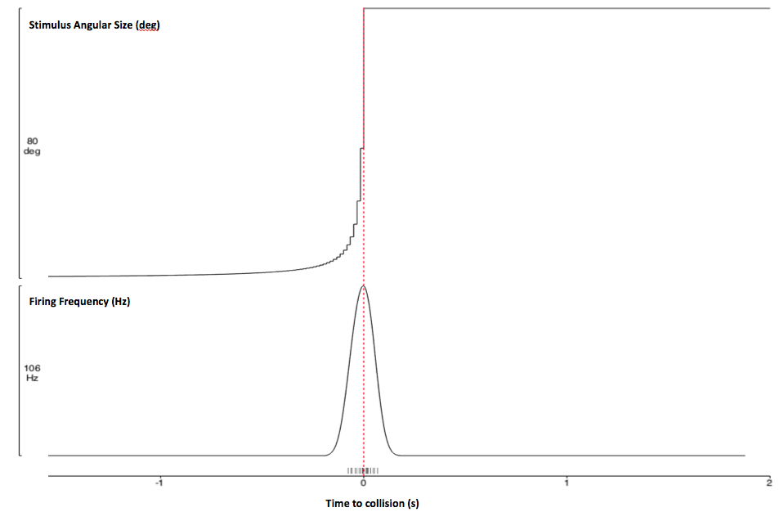

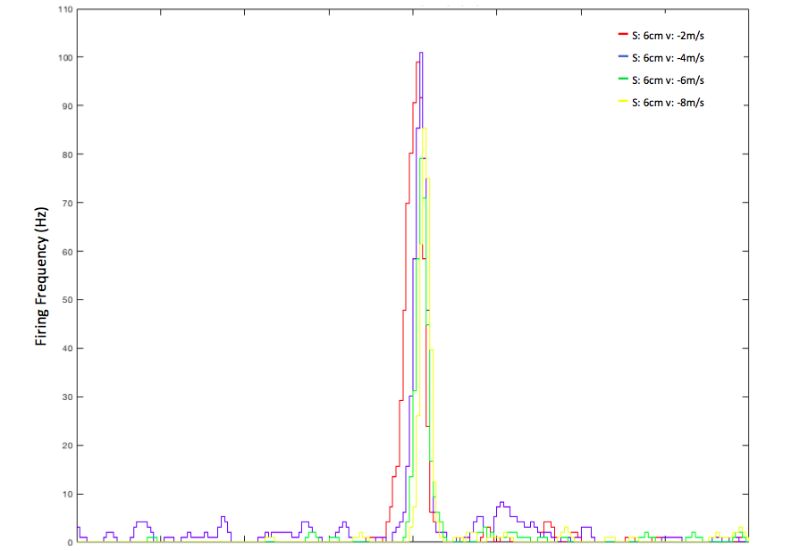

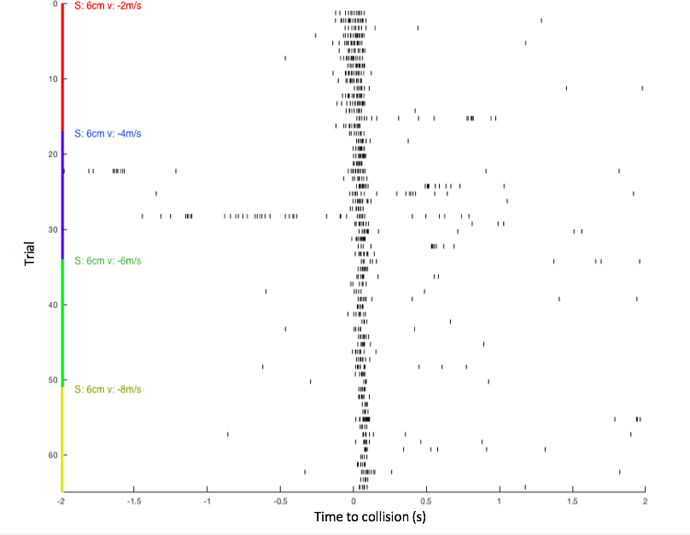

**Fig 4. DCMD response to approaching objects.** d: 10cm; S: 6cm; v: -2, -4, -6, -8m/s; trials per pair of S and v: 30; ITI: 45s. Collision at 0s. **(A)** DCMD activity over time and change in angular size. **(B)** Perievent histogram (PETH; bin size: 0.03s) of DCMD firing frequency 2s before and after simulated collision between eye and object. **(C)** Raster plot of DCMD spiking pattern across each pair of S and v over time. DCMD firing peaks around collision for objects approaching at -2m/s, and after collision for objects approaching faster.

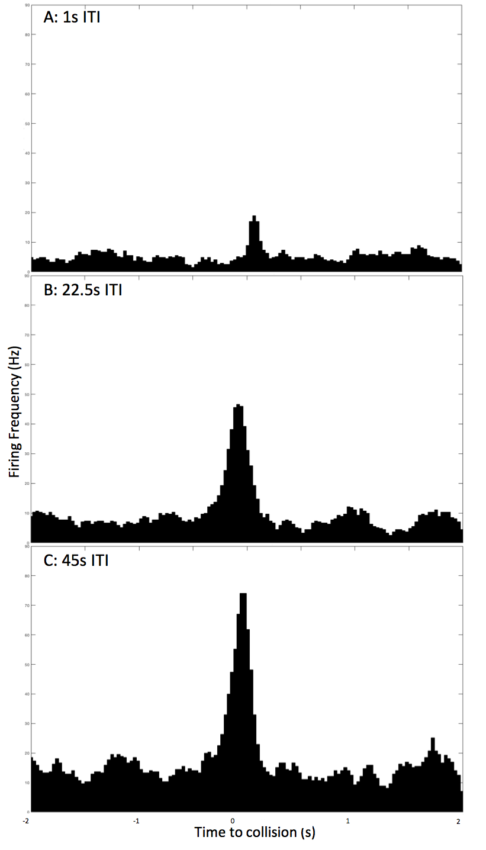

**Fig 5. DCMD response to varying intertrial intervals.** Peak firing frequency is around 20, 45, and 75Hz for 1, 22.5, 45s ITI, respectively. The 45s ITI shows the most consistent and frequent firing of the DCMD, and is the ITI of choice for other experiments.

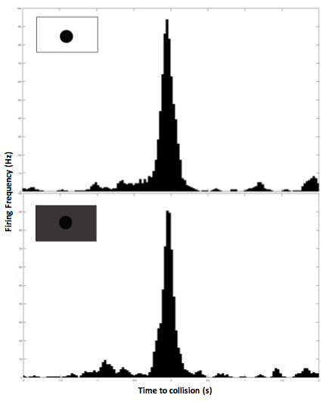

**Fig 6. DCMD response to varying iPad screen brightness.** (top) At maximum brightness, DCMD firing rate is consistent and peaks at 95Hz. (bottom) At minimum brightness, firing rate peaks at 90Hz and is not significantly different from activity pattern at full screen brightness.

**Audience/Journals**

**JUNE**

* Deadline for spring issue: Jan 15
* “Manuscripts should be accompanied by a cover letter from the corresponding author that briefly describes the significance and originality of the work, indicates that the manuscript has neither been published nor under consideration at another journal, indicates that the work adhered to appropriate ethical guidelines for any human and/or animal experimentation, discloses any potential competing interests, and indicates that all authors have agreed to submission of the manuscript and to pay any publication charges assessed (see below). Contact information for at least four potential peer reviewers should also be included in the cover letter. Potential reviewers should be experts in the field, able to objectively assess the manuscript, and not current or recent collaborators.”
* Formatting guideline: <http://www.funjournal.org/for-authors/>

**Materials & Methods**

*Animals & Electrophysiology Preparation*

Due to dependence on local availability and catching abilities, both adult and nymph, male and female, grasshoppers (species *Melanoplus femurrubrum* and *Melanoplus differentialis*) were caught in Nichols Arboretum, MI, in June and July 2016. The animals were refrigerated (average temperature 3ºC) until the experiments (average 4 days).

To prepare for extracellular recording of the DCMD neuron, the grasshopper, further anesthetized in ice for 15 min after storage in the fridge since being caught, was taped ventral side up onto a corkboard on the SpikerBox, with its head and part of the thorax exposed. Its head was pulled back by thread taped to the SpikerBox to expose the neck connectives, where the contralateral nerve cord and DCMD axon could be found. The neck connectives could be seen with the naked eye, but an AmScope SE400-Z binocular microscope with 20X magnification was used for more precise visualization and electrode placement. A small incision in the middle of the neck was made using a 0.3mm insect pin. Then, the recording hook electrode (silver wire, 0.127mm), guided by the Backyard Brains 3D printed micromanipulator, was placed into the incision and around the neck connective contralateral to the eye that would be exposed to the visual stimuli and was insulated with Vaseline, which also kept the incised part from drying out. The reference electrode (silver map needle, 0.6mm diameter) was grounded in the grasshopper’s thorax. Proper electrode position was confirmed by recording DCMD responses (see below) when the grasshopper was exposed to an approaching plastic stick. For the experiment to begin, the longitudinal axis of the grasshopper’s body was oriented parallel to the iPad 10cm away such that the angle between the eye and the center of the screen was less than 1º. The setup was placed inside a cardboard box for maximal surrounding darkness during all experiments except the brightness tests.

*Visual Stimuli & Spike Amplification, Recording, and Sorting*

Electrophysiological measurements were carried out using the low-cost and open-source bioamplifier, the Spikerbox v.1.3c, developed by Backyard Brains (BYB). The SpikerBox has a 4x gain instrumentation amplifier, 220x gain amplifier bandpass-filtered 340-1300Hz, and a 20x gain audio amplifier. It also contains an input port for a Radioshack mini speaker (blue port and cable) and an output port for laptops and smartphones (green port and cable) to make neural activity audible and recordable. During all experiments, the blue and green cables were connected.

The BYB SpikeRecorder iPad application provides both the monocular visual stimuli and recording of DCMD activity. Visual stimuli consisted of expanding dark dots (of various initial radii, S, and velocities, v) on a white background to simulate an approaching and colliding object. Parameters in the application include: distance between subject and stimulus/screen (fixed at 10cm), object size S (list all S) and velocity (list all v), inter-trial interval (list all v) (this was the amount of time between the end of the previous visual display and the commencement of the next looming trial, the iPad displays a blank white screen during this interval), and number of trials. Stimuli of particular parameters S and v are pseudo-randomly presented by the application such that each parameter is repeated 15 times. Recordings were done in the dark for maximal contrast intensity. Spikes were sorted from noise after recording in the iPad application. Sorting the spikes from one recording for one trial (one S, one v) allowed global sorting for the rest of the trials in one experiment.

*Checking the synchronization between simulated and recorded time of collision*

[How to include this section?]

To confirm that the SpikeRecorder accurately records the simulated time of collision, we performed tests to check for the synchronization between the recorded and stimulated time of collision (0s on the perievent and raster plots).

First, the refresh rate of the iPad screen was measured. A phototransistor (state model / manufacturer) was placed 10cm from the screen, to ensure that it would get light from the whole screen, and a single trial of the approaching stimulus was run. The recording output of the phototransistor was observed on an oscilloscope (model / manufacturer – settings if possible / applicable). The duration of one frame was 16.8ms, corresponding to 60Hz refresh rate (60 frames per sec) of the iPad screen. We then calculated the delay between the recorded time of collision on the software and the actual time when the stimulus filled up the whole iPad screen for each S and v parameter (see above). A delay of up to 60ms for the fastest stimuli (e.g. velocities v of -8 and -10m/s) was recorded.

*Classic DCMD Experiments*

Classic DCMD experiments were carried out with 19 grasshoppers and 11 were selected for analysis. The grasshopper was exposed to visual stimuli on the iPad while the SpikeRecorder application recorded DCMD activity amplified by the SpikerBox. Stimuli approach the grasshopper’s eye on a direct collision course. Parameters kept constant across all DCMD experiments were: 10cm distance between the grasshopper’s eye and the iPad; 16 trials per pair of S and v; and intertrial intervals, ITI, of 45s to reduce habituation of the DCMD response to visual stimuli. Each stimulus is a pair of S (6 and 8cm) and v (-2, -4, -6, -8m/s). Initially, two separate experiments of stimuli with constant S and varying v were performed on the same grasshopper. However, to prevent the effect of habituation of the DCMD to the stimuli presented later in a second experiment, the SpikeRecorder application was modified to pseudo-randomly present stimuli of varying S and v throughout a continuous experiment of approximately 2 hours, 128 trials.

*Intertrial Interval Experiments*

To justify the use of an ITI of 45s between stimulus presentations as a sufficiently long interval to avoid habituation to the stimuli, ITI experiments were carried out with 2 grasshoppers. Constant parameters included 10cm distance between eye and iPad, 30 trials per ITI, and one pair of S (6cm) and V (-2m/s). Three ITIs were chosen: 45, 22.5, and 1 second and the total experiment consisted of 90 trials.

*Screen Brightness Experiments*

The third set of experiments aimed to test the effect of screen brightness, which affected the contrast intensity of the black stimuli against the white background, on DCMD response. Brightness of the screen was adjusted in the Settings of the iPad, whose brightness is 426 cd/m2 at maximum and 6 cd/m2 at minimum. Maximum and minimum (not complete darkness) brightness levels were set for two separate experiments. Constant parameters included 10cm distance between eye and iPad, 45s ITI, 20 trials per brightness level for 40 trials total, and one pair of S (6cm) and V (-2m/s).

*Data Analysis*

The SpikeRecorder app includes data analysis functionality. DCMD activity in conjunction with change in angular size of the visual stimulus over time can be visualized in perievent histograms and raster plots, with time to collision defined as 0 seconds.

For more in-depth analysis, data, recorded and contained by the SpikeRecorder application in Json files, were imported into MatLab (MathWorks, Inc.). A database of the experimental data (recording and spike timestamps, stimulus angles, time of collision) was created. Perievent time histograms and raster plots were plotted to visualize firing rate and timing of spikes in relation to stimulus.

***Statistical analysis? Mean firing rates; compare rates for diff S/V, ITI, brightnesses

**Results**

*DCMD response to simulated approaching stimuli*

The visual stimuli in form of enlarging circles simulate approach toward the grasshopper. The circles started at a distance from the eye where their images subtend a minimal angle. Example extracellular recordings of DCMD response for circles 6cm in radius approaching at four velocities (-2, -4, -6, -8m/s) are shown in Fig. 2. At slower velocities (-2 and -4m/s), peak firing occurs before the time to collision between the eye and the stimuli. At faster velocities (-6 and -8m/s), DCMD firing peaks approximately 0.05 to 0.125s after collision.

*DCMD activity during various intertrial trials*

It is known that repeated stimuli could induce habituation of the response. We investigated the effect of various ITIs on DCMD activity, shown in Fig. 3. As expected, an ITI of 1s yields low firing frequency (approximately 20Hz), compared to the frequencies with ITIs of 22.5s (45Hz) and 45s (75Hz). The 45s ITI showed the most consistent and frequent firing, and was the ITI of choice for the rest of the experiments.

*Effect of screen brightness on DCMD response to approaching stimuli*

We also investigated whether screen brightness, which affected the contrast between the stimulus and the screen background, affected the peak response of neuron. As shown in Fig. 4, the DCMD activity profiles at maximum and minimum iPad screen brightness are not significantly different with 90Hz and 95Hz peak frequency, respectively.

**Introduction**

The ability to avoid collision with surrounding objects or escape a predator is crucial to the survival of an animal and requires the visual detection of approaching stimuli and a motor reaction. In the grasshopper visual system, two pairs of well-studied monocular motion-detecting neurons, lobula giant movement detectors (LGMDs) and the descending contralateral movement detectors (DCMDs), underlie the animal’s ability to jump away to escape a potential predator or avoid collision with a looming object. The LGMDs reside in the optic lobe and are excited by approaching visual stimuli. In turn, they send the neural signals to their postsynaptic targets, the DCMDs, which respond to object movements detected by the contralateral eye and activate motor neurons in the thoracic ganglia appropriate to produce the jumping reaction. The LGMDs and DCMDs together make up an early warning system to generate the escape behavior in the face of possible collision with approaching objects.

The LGMD-DCMD system encodes the movement of an approaching stimulus, whose image expands on the animal’s retina. Computer-generated receding stimuli and stimuli whose trajectory to the eye is offset both result in lessened intensity of the DCMD response, which represents the response of the LGDM-DCMD system. This finding suggests that the DCMD is preferential to approaching objects on a direct collision course.

[More background?]

We performed extracellular recordings of the DCMD response to approaching stimuli in grasshoppers using Backyard Brains’ open-source and low-cost equipment. The SpikerBox is a bioamplifier that connects to the SpikeRecorder, a smartphone/computer oscilloscope application that provides the computer-generated visual stimuli as well as serves as the recorder of neuronal activity. This study aims to both investigate the neural basis of motion detection as well as demonstrate the use and efficiency of simple and do-it-yourself neurophysiology tools appropriate and valuable for enhancing the undergraduate understanding of the fundamental properties of the brain.

**Discussion**

Interpretations - how results support the answers & how the answers fit with existing knowledge

Implications

Future improvements

Specific to general: findings to the literature, theory, practice

The LGMD-DCMD system demonstrates the functionality of…

**Title & Abstract**

Observing neural responses to visual stimuli can provide compelling neuroscience demonstrations and excellent student laboratories, however experimental setup can be highly complex and expensive.  In this study, we aimed to simplify a vision-related procedure using open-source and low-cost electrophysiology equipment to extracellularly record and analyze the descending contralateral movement detector (DCMD) neuron that underlies the grasshopper's motor sensitivity to looming monocular visual cues.  In the natural environment, this visual and motor response serves as an escape mechanism for the grasshopper, a prey for a variety of animals including birds and larger insects. We used a low-cost bioamplifier, the Backyard Brains SpikerBox, to amplify DCMD activity and developed a custom iPad app which provides the visual looming (direct collision course) stimuli while simultaneously recording the DCMD neural activity. DCMD firing frequency increased approximately 1.8s after the onset of the stimulus and peaked around the time of collision between the object and the eye, when the object's image on the grasshopper's retina reaches a certain angular size (80º). We also found that the DCMD response habituation can be avoided with an inter-trial-interval of 45s or longer, and that DCMD firing frequency is unaffected by the iPad intensity or by the contrast between the simulated object and screen background. Taken together, we feel this experiment will is tractable to be implemented in secondary education or undergraduate laboratories.

**References**

* Example FUN papers:
  + Nesbit 2015 - Extracellular Recording of Light Responses from Optic Nerve Fibers and the Caudal Photoreceptor in the Crayfish
* SpikerBox paper: <http://journals.plos.org/plosone/article?id=10.1371/journal.pone.0030837>
* Locust DCMD papers:
  + Rind 1992 - Orthopteran DCMD Neuron...
  + Hatsopoulos 1995 - Elementary Computation of Object Approach…
  + Gabbiani 1999 - Computation of Object Approach…
  + Rind 1999 - Seeing What is Coming...
  + Gray 2001 - Activity of DCMD Neurons...
  + Card 2012 - Escape behaviors in insects

**Additional figures to include**